**CAPSTONE PROJECT MEDICARE SPECIFICATION DOCUMENT:**

**Description:**

To develop a dynamic and responsive web application for online ordering of medicines through Medicare Application. Medicare is a company that supplies medicines and a couple of other healthcare essentials at an affordable price. It was established in 2012 in Delhi, India.

**Project Features:**

1. Medicare application is made specifically to the required business needs. It is completely flexible and scalable to business demands and growth.

2. The whole application is a Single Page Application that is more efficient in terms of processing and provides a seamless user experience.

3. The application web pages are responsive and secure.

4. The application has one Administrator. The Admin Portal features are: • The admin can login with username and password in admin portal.

* The admin can add or remove medicine details.
* Edit medicine details like name, price etc., to keep the product information updated with current prices. Enable or disable the medicines.

5. The application has a user portal. The User Portal features are: • Sign up and login with username and password.

* The User can maintain the record of activities.
* Search for products based on the search keyword.
* Apply filters and sort results based on different categories.
* Add the product to cart and customize the purchase at the end.
* Experience a seamless payment experience. • Receive an order summary once the payment is successful.

**Concepts Involved in the project:**

* Angular framework for frontend UI’s.
* Spring boot framework for backend.
* MySQL Database for storing all the data.
* HTML, Bootstrap 4.
* Typescript.
* Spring Security and JWT Authentication.
* Spring Data Jpa, Spring Web.

**Architecture:**

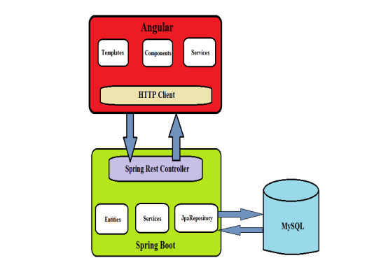

**GitHub Link:**

<https://github.com/SandeepKumarPamu/Medicare.git>